PE01 Kate Weller

React App: <https://automatic-space-doodle-g4q4r6gj74wjfw456-3000.app.github.dev/>



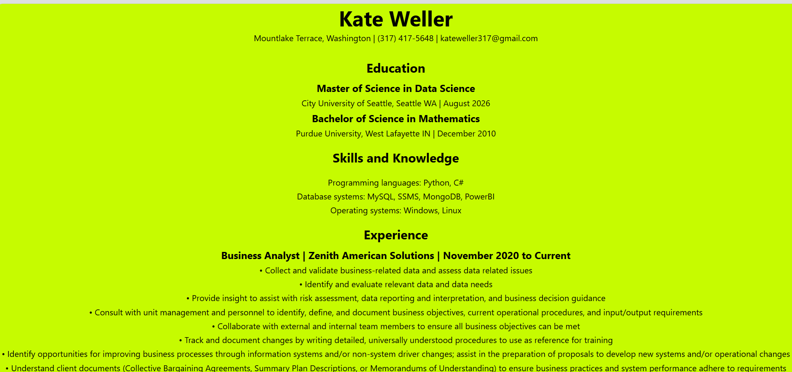

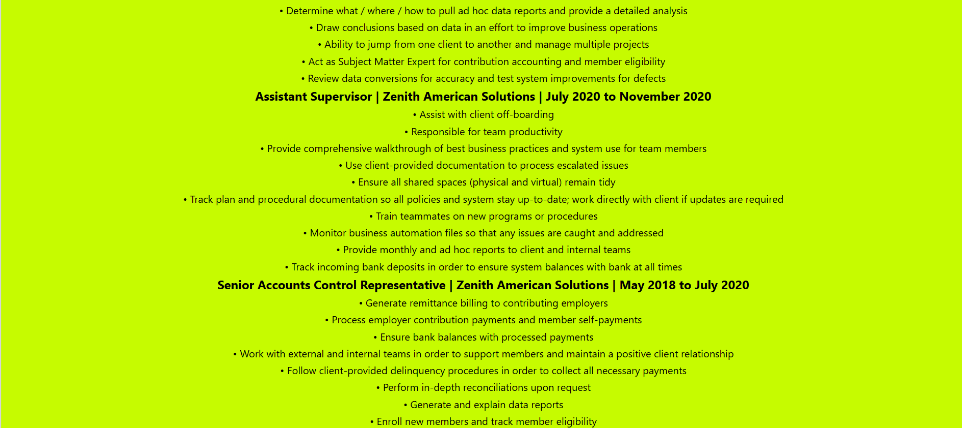 

Source code: <https://github.com/GoobleMoose/Kate_Weller_Resume>